Where Passion Meets Perfection: Maserati Ascot and the Maserati Club Unite to Reward Maserati Ownership
November 2025 - In a first-of-its-kind collaboration, Maserati Ascot launches Exclusive Club Benefits for Maserati Club Members
Following a standout debut collaboration at the prestigious Drivers Union Awards, held during the London Concours on 5 June 2025, Maserati Club UK members voted Maserati Ascot the Best Maserati Main Dealership in the United Kingdom — an accolade that celebrates both innovation and service excellence at the highest level of the Trident marque.
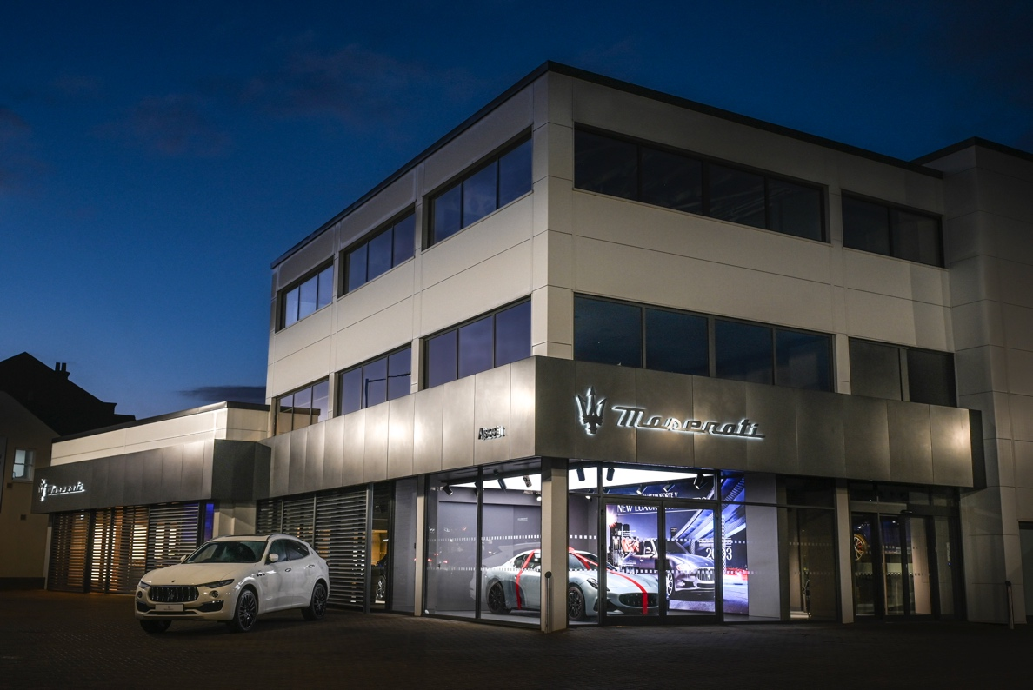
Howard Rose, Managing Director of Maserati Ascot, remarked: “We are honoured to receive this recognition from the Maserati Club. It’s a privilege to serve such passionate owners, and we’re proud to be part of the Maserati family.”

Exclusive Benefits for Maserati Club Members
The partnership now deepens even further. Effective immediately, Maserati Club UK members will enjoy exclusive reduced rates on servicing and genuine Maserati parts at Maserati Ascot:
- Up to 10 % off Parts
- Up to 20 % off Labour
This initiative reinforces the Maserati Club’s long-standing ambition — ensuring that Maseratis of every era are maintained to the highest standards, preserving their performance and elegance for generations to come.
Michael Roberts of Maserati Club UK added: “We’re delighted by the tangible value Maserati Ascot is offering our members. It embodies the Club’s ethos of keeping these extraordinary cars in excellent condition.”

A New Way to Join the Maserati Family
Coinciding with the upcoming launch of the new Maserati Club UK website, Maserati Ascot customers purchasing a new or pre-owned Maserati will be offered automatic Maserati Club membership at a 50 % reduced first-year rate.
This unique initiative enhances the ownership experience — inviting new Maserati owners to join the brand’s official community, participate in exclusive driving and social events, and celebrate over 110 years of Maserati heritage with like-minded enthusiasts.
Howard Dalziel, Maserati North Europe, commented:
“The Maserati Club is unique, as the brand’s only official club, it offers owners an authentic way to experience the Maserati brand both nationally and internationally. We value the Club’s ongoing support in bringing the Maserati world together.”
Follow us on Facebook and Instagram

For further information:
The Maserati Club UK is the only official UK club for owners and enthusiast of the marque recognised by Maserati S.p.A Owners Clubs. Founded in London in 1972, for over 50 years it has organised a wide range of events and tours for its members. It has established a series of local hubs to provide greater member participation throughout the country, and it is officially present at several of the major car events throughout the year. It strives to have close relations with the factory, dealerships and service centres. It publishes Trident magazine and a regular Newsletter. There is a website where all the latest information and news can be found – www.maseraticlub.co.uk. Joining the Club is easy through the Club website.

Maserati Club UK
KURT VAN DEN EYNDEN – Public Relations, Maserati Club UK – publicrelations@maseraticlub.co.uk

Maserati Ascot part of the award-winning Sytner Group, is one of the UK’s flagship Maserati dealerships, renowned for its passion, craftsmanship, and customer care.

